MUHAMAD FAHMI

TINFC-2022-02

20220810029

Tugas Post Test

1. #include<iostream>

using namespace std;

main()

{

int nilai_a, nilai_b, nilai_c, nilai_d, nilai_e, nilai_f, nilai_g;

nilai_a =100;

nilai_b =90;

nilai_c =80;

nilai_d =70;

nilai_e =60;

nilai_f =50;

nilai_g =40;

cout<<nilai_a<<endl;

cout<<nilai_b<<endl;

cout<<nilai_c<<endl;

cout<<nilai_d<<endl;

cout<<nilai_e<<endl;

cout<<nilai_f<<endl;

cout<<nilai_g<<endl;

return 0;

}

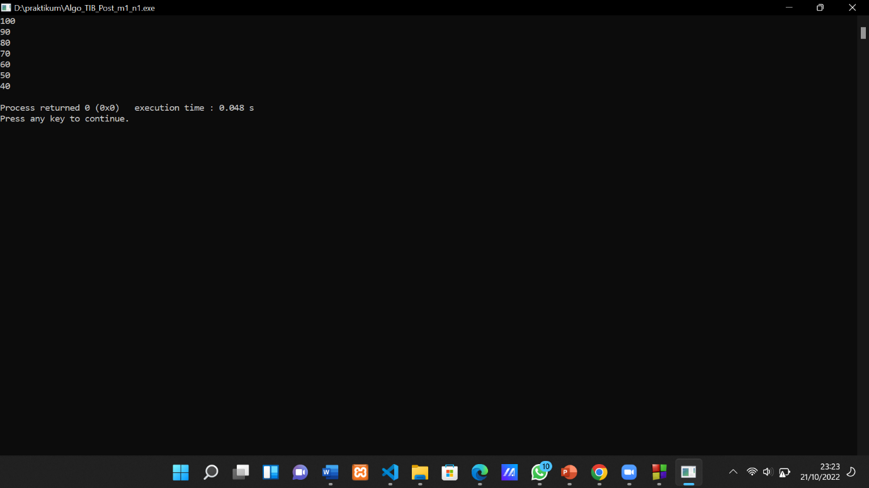

1. #include <iostream>

using namespace std;

int main() {

float a,b,hasil;

char aritmatika;

cout<<"selamat datang di program calculator\n\n";

//masukan input dari user

cout<<"masukan nilai pertama : ";

cin>> a;

cout<<"pilih operator +,-,/,*: ";

cin>> aritmatika;

cout<<"masukan nilai kedua : ";

cin>> b;

cout<<"\nhasil perhitungan : ";

cout<<a <<aritmatika <<b;

if (aritmatika == '+'){

hasil = a + b;

}else if (aritmatika == '-'){

hasil = a - b;

}else if (aritmatika == '/'){

hasil = a / b;

}else if (aritmatika == '*'){

hasil = a * b;

}else {

cout<<"operator anda salah"<<endl;

}

cout<<"=" << hasil <<endl;

return 0;

